ROADMAP LLD (Live Cohort below)
Any Doubts :
Ping me on whatsapp(Number below) “Hello Pradeep need 1:1” I will call you back for guidance for free.

Phase 1: OOP Foundations (Week 1)
Must-know concepts
- Encapsulation (private state, public behavior)
- Abstraction vs Interface
- Inheritance (when NOT to use it)
- Polymorphism (runtime > compile-time)
- UML Diagrams
Interview expectations
- Correct class responsibility
- Proper access modifiers
- Clean constructors
Practice mini-designs
- Design a Printer
- Design a BankAccount
- Design a Car with Engine abstraction

Phase 2: SOLID Principles (Week 2)
This is non-negotiable for SDE-2.
SRP – Single Responsibility
One class = one reason to change
OCP – Open Closed
Open for extension, closed for modification
LSP – Liskov Substitution
Child should be replaceable by parent
ISP – Interface Segregation
Many small interfaces > one fat interface
DIP – Dependency Inversion
Depend on abstractions, not concretes
Always explain what problem each principle solves.
Phase 3: Design Patterns (Week 3–4)
Focus on when & why, not memorization.
Creational
- Singleton (thread-safe)
- Factory
- Abstract Factory
- Builder
Structural
- Adapter
- Decorator
- Facade
- Composite
Behavioral (Very important)
- Strategy ⭐⭐⭐
- Observer ⭐⭐⭐
- Command
- State
- Chain of Responsibility

Most LLD problems reduce to Strategy + Factory + Composition

Phase 4: Concurrency in LLD (Week 5)
SDE-2 often includes thread-safety discussion.
Must-know
- synchronized
- volatile
- Lock, ReentrantLock
- Executors
- Thread-safe Singleton
- Producer-Consumer
Apply in designs
- Thread-safe Cache
- Rate Limiter
- Parking Lot entry system
Phase 5: Core LLD Interview Problems (Week 6–8)
These are absolute must-designs 👇
Beginner
- Design a Logger
- Design a File System
- Design a Vending Machine

Intermediate (SDE-2 Sweet Spot)

- Parking Lot System
- Elevator (Lift) System
- LRU Cache
- Rate Limiter
- Online Chess Game
- Splitwise (Expense Sharing System)
- Movie Ticket Booking System
- ATM System
- Notification System
- File System (Simplified)
- Ride Booking System (Uber/Ola)
- URL Shortener
- Logger System
- Vending Machine
- Online Shopping Cart
- Hotel Booking System
- Snake and Ladder Game
- Library Management System
- Task Scheduler
- Cache with Expiry (TTL Cache)

If you struggle with LLD, then I’ve launched a live classes course starting 17 Jan, everything above will be covered.

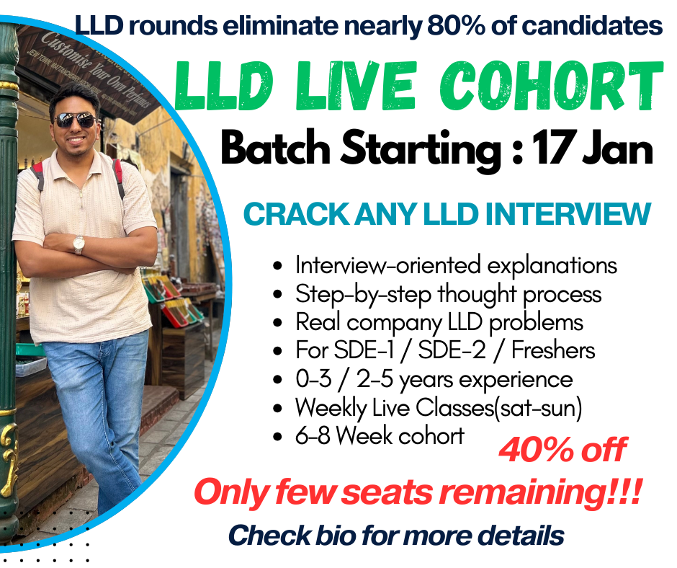

“I keep batches small so pricing reflects personal involvement.”
Enroll:https://forms.gle/3tWy6qURHeyRTVmG9

Any Doubts :
Ping me on whatsapp 9871043556 “Hello Pradeep need 1:1” I will call you back for guidance for free.

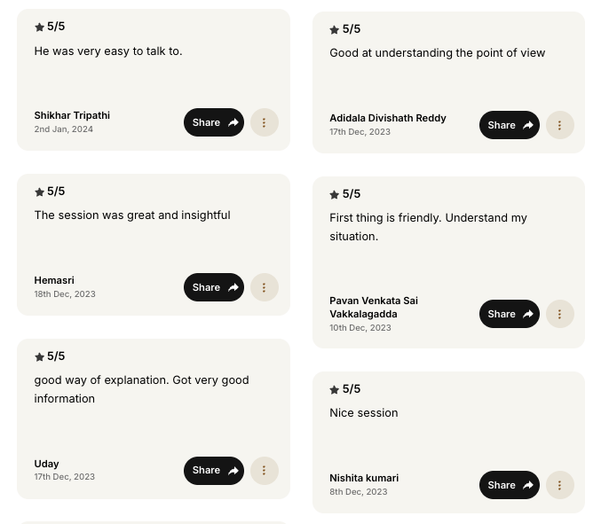

System Design Roadmap[These are must rest is optional]
Foundations
- Client–Server model
- HTTP / REST basics
- Latency vs Throughput
- CAP theorem
Scalability Basics
- Vertical vs Horizontal scaling
- Stateless vs Stateful services
- Load balancing basics
Databases
- SQL vs NoSQL
- Indexing & sharding
- Replication & consistency
- Read vs write optimization
Caching
- Why caching is needed
- Cache-aside pattern
- Redis / Memcached basics
- Cache invalidation strategies
API Design
- RESTful API design
- Idempotency
- Pagination & filtering
- Versioning
Asynchronous Processing
- Message queues
- Pub–Sub model
- Event-driven architecture
- Background jobs
Consistency & Reliability
- Strong vs eventual consistency
- Idempotent consumers
- Retry, timeout, circuit breaker
Distributed Systems Concepts
- Leader election
- Distributed locking
- Heartbeats & failure detection
Security & Observability
- Authentication & authorization
- Rate limiting
- Logging, monitoring, alerting
Interview Questions
- URL Shortener
- Chat application
- Feed system
- Rate Limiter
- File storage system
- And Many more

